Item | Description of key inspection items | Determination result | Remarks / Reassessment and Evaluation
chemical management | 1. Prepare a "Hazardous Chemicals List", Print on paper, sign with the manager's name and date, and store it at the chemical storage site.  Description: Chemicals should be registered in the "Ministry of Education Chemical Management System" and "Hazardous Chemicals List" should be made using the system. | □YES (Meet the requirements)  □NO (Does not meet requirements)  N/A(not applicable) | ◎critical safety items  ○common items for external audits
chemical management | 2.Every month, upload the 'Hazardous Chemicals List' and the”Hazardous Chemicals Operation and Storage Management Self-Checklist”  Description: Please refer to the Environmental Safety Office webpage >Occupational Safety Section>Laboratory Safety>Hazardous Self_checking | □YES (Meet the requirements)  □NO (Does not meet requirements)  N/A(not applicable) | ◎critical safety items
chemical management | 3. Prepare safety data sheets(SDS) for hazardous chemicals and place them in a prominent place in the laboratory.  Description: Safety data sheets must be in Chinese, the printed date or inspection date must be within three years. Other language versions can be requested from suppliers as needed. | □YES (Meet the requirements)  □NO (Does not meet requirements)  N/A(not applicable) | ○common items for external audits
chemical management | 3. Containers of hazardous chemicals should be clearly labeled according to the "Regulations on the Labeling and General Knowledge of Hazardous Chemicals".  - Hazard pictograms (GHS)(red frame, white background, and black text)  - Name  - Hazard ingredients  - Warning words  - Hazard warning messages  - Precautionary measures  - Manufacturer or supplier name  - Address and phone number | □YES (Meet the requirements)  □NO (Does not meet requirements)  N/A(not applicable) | ○common items for external audits
chemical management | 4. Toxic chemicals should be stored in dedicated cabinets and locked, with keys kept separately.  Description: Toxic chemical storage cabinets need to be labeled externally. | □YES (Meet the requirements)  □NO (Does not meet requirements)  N/A(not applicable) | ○common items for external audits
chemical management | 5. Accurately fill in the operation records of toxic chemicals in the management system and report on time every quarter (January, April, July, October). | □YES (Meet the requirements)  □NO (Does not meet requirements)  N/A(not applicable) | ○common items for external audits
chemical management | 6. Organic solvents should be stored in ventilated storage cabinets (not chemical fume hoods), and the ventilation function of the storage cabinets should be normal. | □YES (Meet the requirements)  □NO (Does not meet requirements)  N/A(not applicable) | ○common items for external audits
chemical management | 8. Chemicals should be stored separately according to their properties and clearly labeled with prominent text (e.g., strong acids and strong bases), and anti-spill or anti-overflow measures should be implemented..  Description: It is recommended that liquid and glass-bottled chemicals be placed on lower levels to avoid damage in case of a fall. | □YES (Meet the requirements)  □NO (Does not meet requirements)  N/A(not applicable) | ◎critical safety items  ○common items for external audits
chemical management | 8. Chemical storage cabinets should be equipped with anti-fall bars to prevent chemicals from falling accidentally.  Description: It is recommended that liquid and glass-bottled chemicals be placed on lower levels to avoid damage in case of a fall. | □YES (Meet the requirements)  □NO (Does not meet requirements)  N/A(not applicable) | ◎critical safety items  ○common items for external audits
pathogen management | 1. Laboratories operating RG1-RG4 pathogens or infectious biological materials must be reviewed and approved by the university's "Biosafety Committee" before conducting experiments. | □YES (Meet the requirements)  □NO (Does not meet requirements)  N/A(not applicable) | ○common items for external audits
pathogen management | 2. Laboratories handling pathogens and biological toxins of risk group 2 and above should handle the following matters:  (1)、Appoint a dedicated person responsible for management.  (2)、Access control.  (3)、Regular disinfection.  (4)、Monitor personnel health and keep records.  Description: Unauthorized personnel should not enter the restricted area. | □YES (Meet the requirements)  □NO (Does not meet requirements)  N/A(not applicable) | ◎critical safety items  ○common items for external audits
pathogen management | 3. Before the end of each quarter (March, June, September, December), ensure that the pathogen and biological toxin data maintained in the laboratory is confirmed in the Disease Control Agency's "Laboratory Biosafety Management Information System." | □YES (Meet the requirements)  □NO (Does not meet requirements)  N/A(not applicable)
laboratory waste | 4. Personnel entering BSL1 and BSL2 laboratories must complete education and training (8 hours for new staff, 4 hours of continuing education annually). | □YES (Meet the requirements)  □NO (Does not meet requirements)  N/A(not applicable) | ◎critical safety items  ○common items for external audits
laboratory waste | - Accurately classify general/harmful industrial waste. | □YES (Meet the requirements)  □NO (Does not meet requirements)  N/A(not applicable) | ○common items for external audits
laboratory waste | - Properly use "red biomedical waste bags" to contain infectious industrial waste. | □YES (Meet the requirements)  □NO (Does not meet requirements)  N/A(not applicable) | ○common items for external audits
laboratory waste | - Prepare your own puncture-resistant containers to collect sharp waste such as needles and glass slides. Obtain biomedical waste labels from the Environmental Safety Team and affix them to the containers.  Description: Do not dispose of sharp objects directly into garbage bags. | □YES (Meet the requirements)  □NO (Does not meet requirements)  N/A(not applicable) | ◎critical safety items  ○common items for external audits
laboratory waste | - Infectious waste bins must be covered with a lid. | □YES (Meet the requirements)  □NO (Does not meet requirements)  N/A(not applicable) | ○common items for external audits
laboratory waste | - Infectious waste must be stored in a freezer at or below 5°C and disposed of within 7 days. | □YES (Meet the requirements)  □NO (Does not meet requirements)  N/A(not applicable)
laboratory waste | - Biomedical waste temporarily stored in a freezer must have a biomedical waste label affixed prominently on the freezer. | □YES (Meet the requirements)  □NO (Does not meet requirements)  N/A(not applicable) | ○common items for external audits
laboratory chemical waste liquids | - Waste liquid containers are issued by the Environmental Safety Team, made of HDPE, with a seal-equipped lid and a capacity of 20 liters. A "spill tray" should be placed underneath the container.  Description: Do not place the waste liquid container directly on the floor. | □YES (Meet the requirements)  □NO (Does not meet requirements)  N/A(not applicable) | ◎critical safety items  ○common items for external audits
laboratory chemical waste liquids | 2. Sort and store waste liquids by type, and label them accordingly.  The waste liquids at this institution are categorized into 12 types:  - Non-halogenated organic solvents  - Halogenated organic solvents  - Cyanide-containing waste  - Heavy metal-containing waste  - Acidic waste  - Alkaline waste  - Hexavalent chromium-containing waste  - Oil and grease  - Inorganic mercury-containing waste  - Fluoride-containing waste  - Developers and fixers | □YES (Meet the requirements)  □NO (Does not meet requirements)  N/A(not applicable) | ◎critical safety items  ○common items for external audits
laboratory chemical waste liquids | 3. After generating waste liquids, immediately secure the lid on the container and record the information in the "Laboratory Waste Liquid Classification and Storage Log." Sign your full name in the "Disposer's Signature" section. | □YES (Meet the requirements)  □NO (Does not meet requirements)  N/A(not applicable) | ○common items for external audits
laboratory chemical waste liquids | 4. Affix the hazardous waste characteristic label to the waste liquid container.  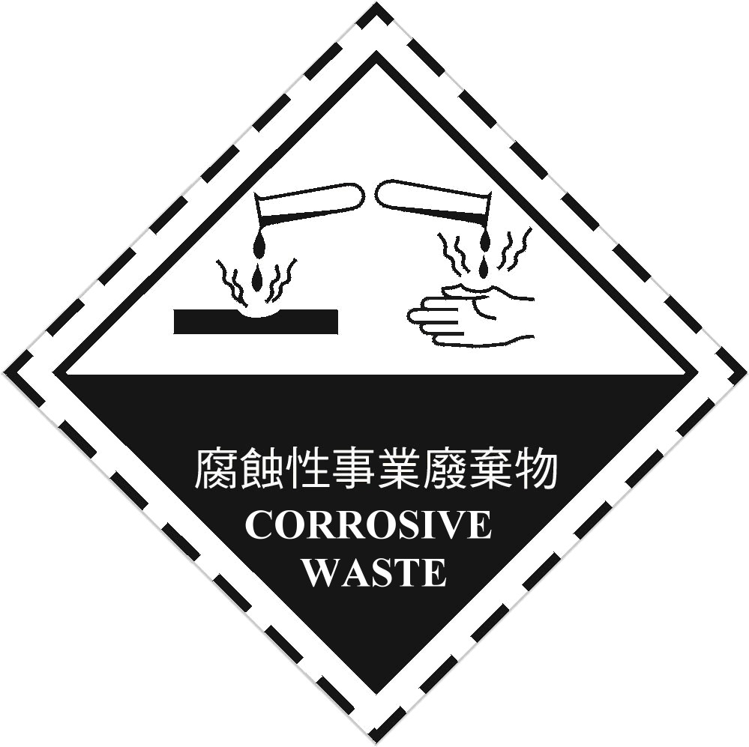  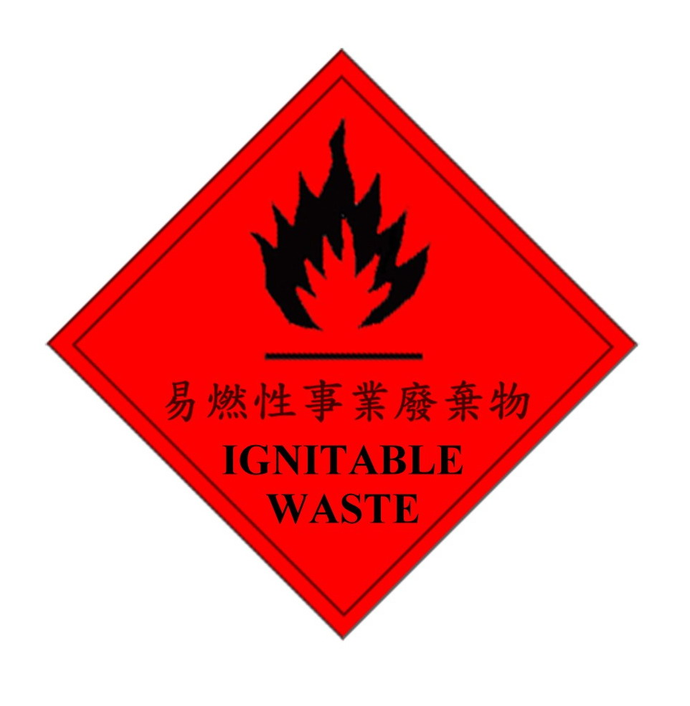  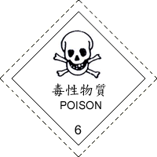 | □YES (Meet the requirements)  □NO (Does not meet requirements)  N/A(not applicable)
regular equipment inspections | 1. Inspect high-pressure steel cylinders used within the unit annually and complete the inspection form.  Description: Cylinders must be secured. Unused cylinders should have their hoses removed and be covered with a protective cap. | □YES (Meet the requirements)  □NO (Does not meet requirements)  N/A(not applicable) | ○common items for external audits
regular equipment inspections | 2. Inspect the chemical safety cabinets within the unit monthly, complete the inspection form, and replace expired items.  Description: Filters in face shields inside the cabinet are considered expired if the seal has been broken. | □YES (Meet the requirements)  □NO (Does not meet requirements)  N/A(not applicable) | ○common items for external audits
regular equipment inspections | 3. Inspect the autoclaves used within the unit annually and complete the inspection form. | □YES (Meet the requirements)  □NO (Does not meet requirements)  N/A(not applicable) | ○common items for external audits
regular equipment inspections | 4. Inspect the dryers and ovens used within the unit monthly and complete the inspection form. | □YES (Meet the requirements)  □NO (Does not meet requirements)  N/A(not applicable) | ○common items for external audits
regular equipment inspections | 5. Inspect the centrifuges used within the unit annually and complete the inspection form. | □YES (Meet the requirements)  □NO (Does not meet requirements)  N/A(not applicable) | ○common items for external audits
regular equipment inspections | 6. Inspect the emergency eye wash and shower equipment within the unit monthly and complete the inspection form. | □YES (Meet the requirements)  □NO (Does not meet requirements)  N/A(not applicable) | ○common items for external audits
regular equipment inspections | 7. Inspect the chemical fume hoods used within the unit annually and complete the inspection form. | □YES (Meet the requirements)  □NO (Does not meet requirements)  N/A(not applicable) | ○common items for external audits
regular equipment inspections | 8. Ensure that all protective equipment is within its validity period.  Description: Verify the functionality of the protective equipment as well. For example, freeze-resistant gloves must be tested to ensure they can adequately withstand the conditions of ultra-low temperature freezers. | □YES (Meet the requirements)  □NO (Does not meet requirements)  N/A(not applicable)
electrical safety | 1.Sockets near water sources should be equipped with protective covers. | □YES (Meet the requirements)  □NO (Does not meet requirements)  N/A(not applicable) | ○common items for external audits
electrical safety | 2.Extension cords must have a certification mark from the Ministry of Economic Affairs. They should not be daisy-chained or used for high-energy-consuming equipment.  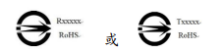 | □YES (Meet the requirements)  □NO (Does not meet requirements)  N/A(not applicable) | ○common items for external audits
electrical safety | 3. Maintain an 80 cm clear space in front of electrical panels within the unit. | □YES (Meet the requirements)  □NO (Does not meet requirements)  N/A(not applicable) | ○common items for external audits
electrical safety | 4. High-energy-consuming equipment with an electric power of more than 1,500 watts must apply to the Office of General Affairs to set up a dedicated circuit. | YES (Meet the requirements)  □NO (Does not meet requirements)  N/A(not applicable)
work environment | 1. Avoid stacking items at high locations. Cabinets, workbenches, and equipment that do not have dedicated storage compartments, anti-fall barriers, or other measures to prevent items from falling should not be used for storage or stacking, in order to prevent falling incidents. | □YES (Meet the requirements)  □NO (Does not meet requirements)  N/A(not applicable) | ○common items for external audits
work environment | 2. In the laboratory, maintain a clear space of at least 80 cm between equipment, workbenches, storage cabinets, walls, and other structures to ensure safe passage and emergency evacuation. | □YES (Meet the requirements)  □NO (Does not meet requirements)  N/A(not applicable)
work environment | 3. In public spaces, corridors must have a width of at least 120 cm to allow for safe passage and emergency evacuation. Equipment placement must not obstruct evacuation routes. | □YES (Meet the requirements)  □NO (Does not meet requirements)  N/A(not applicable)
personnel management | 1. Laboratory staff should participate in safety and health education training as required and pass the exam.  Description: Ensure personnel have obtained environmental safety training certification numbers.  Online courses: https://im.tmu.edu.tw/course/info/10225 | □YES (Meet the requirements)  □NO (Does not meet requirements)  N/A(not applicable) | ◎critical safety items  ○common items for external audits
personnel management | 2. Formulate the "Laboratory Safety and Health Work Code", signed and announced by all laboratory personnel. (Undergraduate students can substitute signing with pre-class announcements if they need to use the laboratory due to coursework.) | □YES (Meet the requirements)  □NO (Does not meet requirements)  N/A(not applicable) | ○common items for external audits
personnel management | 3. Personnel rest rooms and offices should be located outside the laboratory area. | □YES (Meet the requirements)  □NO (Does not meet requirements)  N/A(not applicable)
personnel management | 4. No eating or drinking in the laboratory area (including preparation rooms).  Description: No eating or drinking, no storing of opened or possibly contaminated beverages or food. | □YES (Meet the requirements)  □NO (Does not meet requirements)  N/A(not applicable)
personnel management | 5. Personnel should complete equipment operation training and keep records before operating machinery in the unit.  Description: Each equipment should have a "Safety and Health Work Code". Examples of common equipment codes are available on the Environmental Safety Group website. Units should formulate codes based on their equipment specifications and implement training. | □YES (Meet the requirements)  □NO (Does not meet requirements)  N/A(not applicable) | ◎critical safety items  ○common items for external audits

